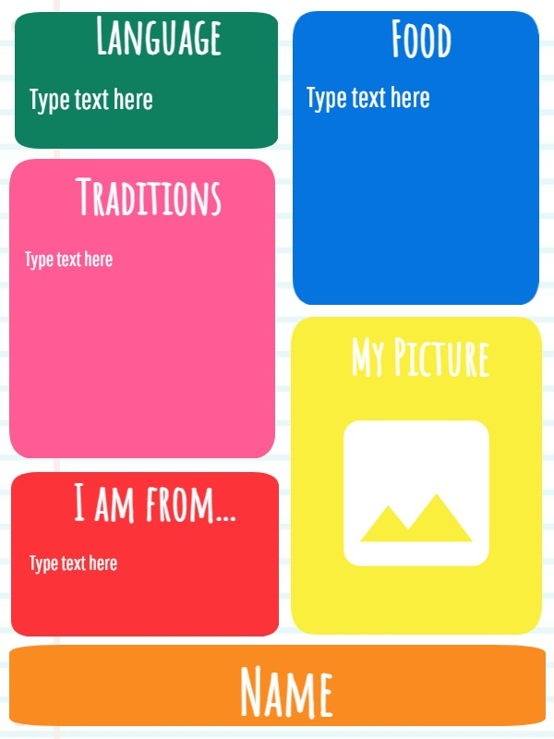
LIST OF FAVOURITE FESTIVALS

